Anatomy

Fill in the blanks in the outline below. Word Bank
Nasal Passage Abdominal Muscles
I. Motor Tongue Vibrators
Diaphragm Teeth
a) _Diaphragm_____________
b) Lungs
c) Ribs

d) __Abdominal Muscles_________

II. __Vibrators___________
a) Vocal Cords

III. Resonators
a) Mouth

b) ___Nasal Passage_________
c) Chest

IV. Articulators
a) Lips

b) _Teeth____________

c) _Tongue____________

Circle the practices that promote good vocal health (5 total).

Whisper Eat healthy/exercise Drink coffee

Drink Water Speak at very high/very low pitch levels Sleep

Avoid Smoke Clear your throat Use breath support when speaking

Multiple Choice

1. Which of the following is included in the nasal passage?

- Mouth
- Cheekbones
- Teeth
- Forehead

2. Which of the following contributes to breath support?

- Abdominal muscles
- Vocal cords
- Diaphragm
- Ribs

3. Which of the following helps to form consonants?

- Motor
- Vibrators
- Resonators
- Articulators

4. Why does your stomach move outward when you inhale?

- Air is entering the stomach.
- The diaphragm moves down, causing the internal organs to be pushed outward.
- Air is entering the diaphragm.

Vocabulary

1. Andante: Walking pace

2. Adagio: Slow

3. Moderato: Moderate speed

4. Allegro: Fast

5. Presto: Very fast

6. Pianissimo (pp): Very soft

7. Piano (p): Soft

8. Mezzo-piano (mp): Medium soft

9. Mezzo-forte (mf): Medium loud

10: Forte (f): Loud

11. Fortissimo (ff): Very loud

12. Crescendo: Gradually get louder

13. Decrescendo: Gradually get softer

14. Slur: A curved line connecting two or more notes of different pitches. Shows that the notes should be sung smoothly and connected.

15. Tie: A curved line connecting two or more notes of the same pitch. Sustain the pitch for the combined value of the tied notes.

16. Legato: Smooth, connected style

17. Staccato: Short, detached style

18. Accent: A sudden, strong stress of a note

19. Fermata: Hold the note

20. Ritardando/Rallantando: Gradually decrease tempo

21. Accelerando: Gradually increase tempo

22. A tempo: Return to previous tempo

23. Dal segno (D.S.): Return to the sign

24. Da Capo (D.C.): From the top

25. Fine: End

26. Coda: Closing section of a piece

27. Interval: Difference in pitch between two notes

28. Arpeggio: A broken chord

29. Half step/semitone: The smallest interval

30. Whole step: Interval as large as two half steps

31. Ledger line: Lines added above or below the staff to show pitches higher or lower than those that can be shown on the staff

32. Extension dot: Adds half of the note’s value to the note

33. Poco a poco: Little by little

34. Piu: More

35. Molto: Much

36. A cappella: Sung without accompaniment

Note Names

Dots on the Bass Clef surround the Swirl on the Treble Clef circles the “G” line.
“F” line.

Lines=Good Birds Don’t Fly Away Lines=Every Good Boy Deserves Fudge

Spaces=All Cows Eat Grass Spaces=FACE

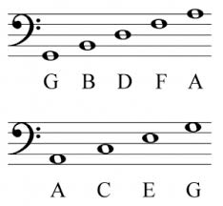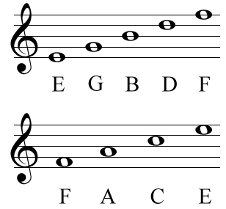

Practice note names: http://www.musictheory.net/exercises/note

Solfege/Takadimi

Make sure you are able to label the solfege and takadimi syllables in the following examples:

Solfege:

Takadimi:
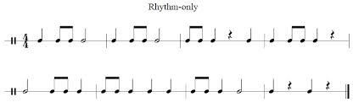

Practice sightreading: www.sightreadingfactory.com

Practice dictation: https://www.teoria.com/en/exercises/rd.php

